**Face Recognition based Attendance Monitoring System**

**Team Members :**

RA1911026010005 - Harshavardhan

RA1911026010009 - A.HariChandana

RA1911026010019 - Sai Pranav

**Abstract :**

Attendance marking in a classroom during the lecture is very monotonous and

time-consuming. Recently, attendance marking with conventional methods has been an area of challenge.So there is a growing need of efficient and automatic techniques of marking attendance.Rather than employing the conventional

techniques, this proposed system intends to implement a labor-saving system.

**Existing system :**

The traditional attendance tracking method includes taking attendance via pen and paper or some other sort of manual system.There also exists other methods such as: Fingerprint and Radio frequency identification tags.

**Issues in Existing system :**

* Requires consistent human intervention.
* High possibility of inaccuracy and error.
* Lack of the element of reliability.
* Time consuming
* Tedious task when the number of students are very high

**Problem Statement :**

Recognizing the person’s face for taking the attendance of the particular person. Given a person’s image or person showing his face to the webcam, the system has to efficiently identify and recognize the person and mark his/her attendance in the excel sheet.

**Objective :**

* The main objective of this Attendance monitoring system using Face recognition system is to make the attendance marking and management system efficient, time saving, simple and reduce the workload.

**Proposed Methodology :**

The proposed system is Attendance automation and management system using face recognition.

* This system captures the image of a person or a picture real-time using a web-cam and recognizes it and automatically enters the attendance of that person.
* It can recognize the person even if his face is tilted a bit.

**Architecture Diagram :**

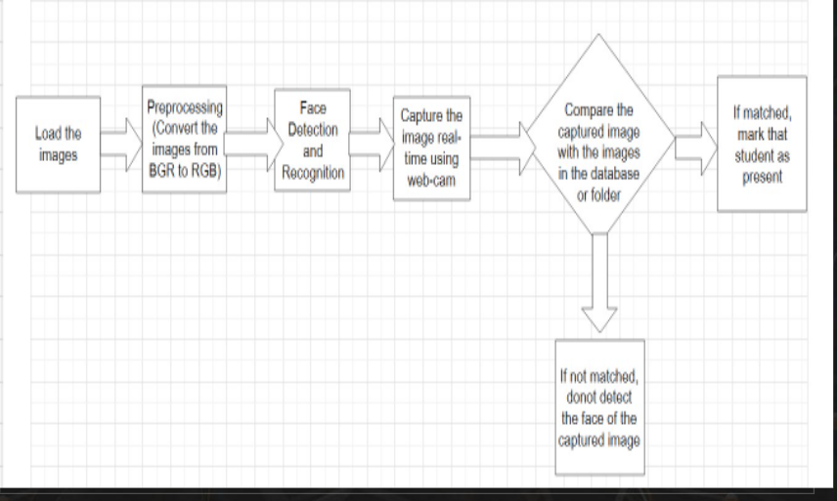

**Demo and Screenshot of Output :**

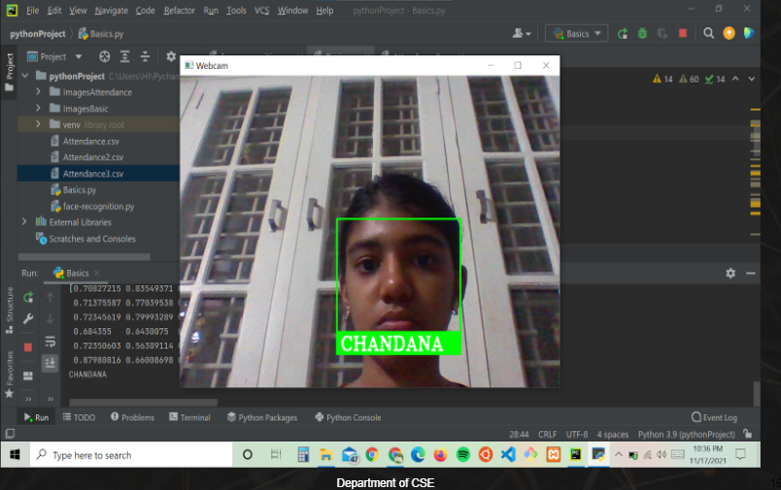

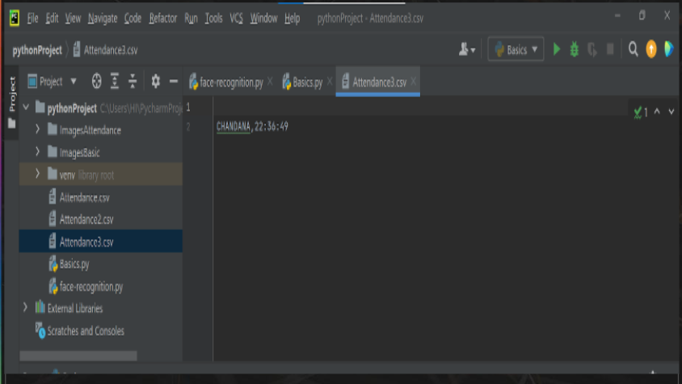

**Github repository link :**

<https://github.com/HariChandana4902/Attendance-Monitoring-System-using-Face-Recogntion>

**Github repository Screenshot :**

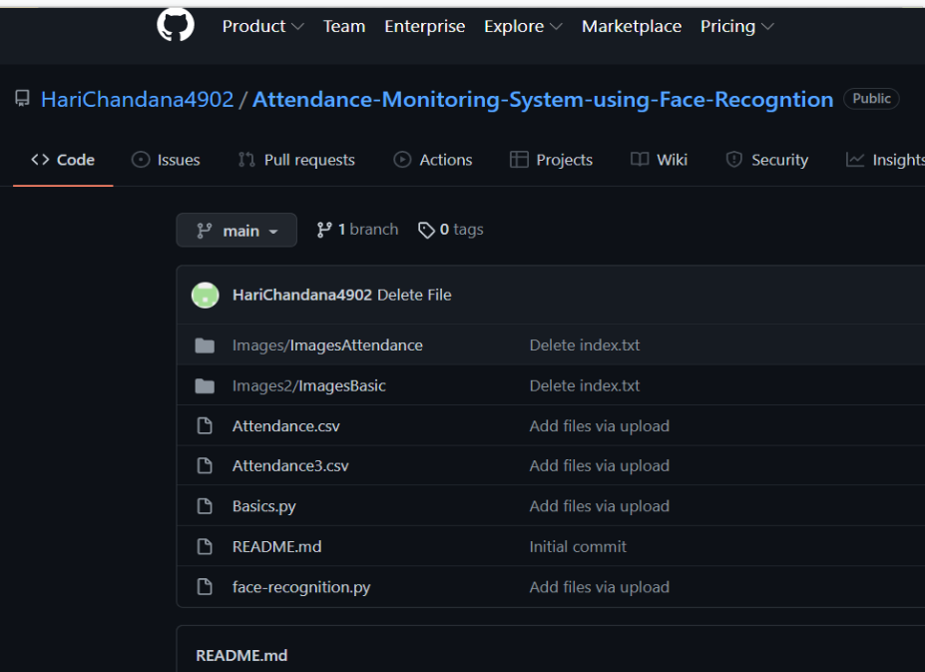

**Purpose of Problem Statement/ Societal Benefit :**

* No need for human intervention
* Cost-effective
* Minimizing physical contact
* Prevent Proxy Attendance
* Easy to Manage
* Smart Integration